Building G FAQ’s: Revised July 11, 2018

- Is the building bigger?

The Building has become taller, but not necessarily bigger. The mass of the revised building is 875 square feet larger than the building we proposed during the Master Plan Special Permit process (188,000 GSF vs. 188,875 GSF). What we are proposing is a more slender building which will improve the pedestrian experience at the ground plane and the views in and out of Arsenal Park.

- Besides making the building taller, what else has changed?

We have reduced the building footprint by 30%, increasing the space between the buildings from 24 feet to 56 feet at the widest point. This reduction in building footprint increases the light and air between Building F & G, doubling the width between the rear of Building F, and the north side of Building G, providing an opportunity to create a pedestrian connection to the park from the east and enhancing the public experience between the buildings at the entrance to Arsenal Park.

As previously designed, the 24 foot space between the buildings was conceived as a loading alley and to allow fire truck access. This wider connection allows for more light and air between the buildings as well as an opportunity to create functional public space along the park.

- How many more units does this taller building represent?

At this time, we are still proposing 122 units in Building G. 122 represents the remaining units left under the original Master Plan Special Permit approval we were granted in 2017. The final unit count will be a function of the building layout and not necessarily its mass and may result in more (or fewer) units as determined by the average unit size, which, for condominium units which may be larger than that of typical rental units.

- How does this taller building impact Arsenal Park?

We believe that the impact from the narrower building is an improvement to the access to Arsenal Park from the east because it creates a wider, more open pedestrian access between Buildings F & G (by more than twice the width)

- The taller building must create more shadow on the Park?

Since the park is located to the south of Arsenal Yards, the majority of the shadow impacts are on the Arsenal Yard’s buildings. The shadow studies show some additional early morning shadows to the west on the summer solstice, which quickly dissipate by mid-morning. The remaining shadow studies show improvements to the shadow impacts to the pedestrian space between Buildings F & G in the early morning and late afternoon.

- Does a taller building mean more wind?

It might. Wind impacts are more a function of exposed surface area than purely of height, so a taller building that is narrower, may have similar or lesser wind impacts than a similar wider and shorter building. Once a building design has been decided, we would undertake a wind study with an engineering firm that specializes in modeling building and wind conditions. The study may require additional wind mitigating features to the building’s exterior such as additional canopies or eyebrows which work to shield the wind from the impacts on the ground.

Similarly, it is our sense that while taller, the narrower building and dramatically wider space between buildings would actually reduce the wind tunnel effect between the buildings in the pedestrian space as compared to existing design.

- Will this increase in height create additional traffic?

No, the traffic counts will remain the same as the total gross SF and unit count of the building has not changed. All of the traffic and parking studies to date have accounted for a building of this size and unit count.

- Once the approvals are received, will you be selling the approvals?

Boylston Properties will remain involved with the development of Building G. We will be finding a development partner who specializes in developing, designing, marketing and constructing “for sale” condominium properties, something that we don’t have expertise in. Boylston/Wilder will continue to be the master developer of Arsenal Yards, and as such will retain control over any future design approvals with limits on what can be proposed by a condominium development partner to ensure that the final design is consistent in quality and massing of what is being proposed. The ultimate design controls, however, will remain with the public process and Planning Board and their design review process.

Over the past five years, throughout all of the approvals at Arsenal Yards, the development of LINX and The Marriott Residence Inn, we believe that we have proposed, and then delivered, high quality buildings that we are proud of, and have met any high standard for the quality of new construction in town. We have received overwhelming support from the Planning Board for our designs. We are extremely proud to develop “Best in Class” properties, and this commitment to design will continue with Building G.

- Does the taller building raise additional tax revenue?

We believe the taller building may generate additional tax revenue for the Town due to the fact that the units, on all floors, will be better units because it is a better building as a result of the revised building width and improved ground plane. A better unit theoretically should be more valuable and therefore the tax assessment on the completed units should be greater.

- Why can’t you just build what was already approved?

We can, however, without the changes we are proposing, we will be permitting a building similar to what was approved which is shorter and wider. We believe that we would be missing an opportunity to build something that is more elegant and special and is clearly a superior design. We believe that reducing the mass of the building at the ground level and narrowing the western building edge that is viewed from Arsenal Park makes the proposed Building G a much better building. The majority of people will experience Building G at the ground, making that the most important element of the design.

- Is this the building you are going to build?

Probably not exactly as what we are showing you today. In order to demonstrate our thoughts on what a taller building could possibly look like, we have asked PCA to complete the preliminary design that you see here. The development process, including the selection of a development partner, the design team, community meetings and planning board review will ultimately determine the final building design.

- Where is the parking for G located?

The lowest floor of the F garage includes 134 spaces dedicated and nested for condo residents only. Depending on the final unit count, one level of additional parking may be added under G which would be connected below grade to F. This additional below grade parking would represent another 40 plus spaces.

- You are creating a public safety issue by building such a tall building.

Building G at either 130 or 197 feet will be built using all non-combustible structural materials (steel or concrete) and will include the latest in building code life safety measures (sprinklers, smoke evacuation systems, fire command communications etc.) making it the safest of all the buildings within the development. Buildings in excess of 70 Feet in height are not meant to be accessed from the exterior in the event of a fire. All of the life safety systems mentioned above allow for fire fighters to access modern high rise buildings from within its core.

- How do we know you will build what you say you will?

We are committed to remaining involved with any new development partner and want to make sure that this new building becomes a project that everyone is proud of. We already have design criteria for this building in the agreements we just signed with our partners and lenders. Boylston Properties is investing over $400M in Arsenal Yards and to design and construct a building that devalues that investment doesn’t make economic sense.

We have established design guidelines for the new building that we will share with the development team and the Town and it is our intention to remain involved in the design and permitting process with the Town. We believe that our most recent buildings, LINX and The Marriott Residence Inn demonstrate our commitment to the Town and to how Boylston Properties envisions and executes high quality buildings.

It’s important to note that while we are amending the zoning to include additional height, it is only the first of multiple steps. The Town will still require that we have additional community meetings, a developer’s conference and present the final proposed plans to the Planning Board for review and input, and then to the Town Council for their review and vote.

- Will there be affordable units in the Condominium building?

Yes, 15% of the units will be affordable and the unit mix of affordable units will match the unit mix for market rate units. At 122 units total units, 19 units will be designated as affordable. Nothing changes with this.

- What will these condos sell for?

We can’t determine that at this point in time. Many economic factors will determine the sale price, including interest rates, construction pricing, material costs, the development pipeline and the general overall economic condition.

- Doesn’t changing the zoning open up all of Watertown to high rise development?

No, our proposed zoning amendment only addresses sites within the RMUD that have at least 10 acres of land. We believe that the 10 acre restriction eliminates all properties within the RMUD with the exception of Arsenal Yards and The Watertown Mall.

- How does this 18-story building compare to other tall buildings in Watertown?

This would be the tallest building in Town. We believe this is an appropriate location for additional height, as it is not within an existing neighborhood and can serve as a contemporary beacon in Watertown, as the Perkins School has been a landmark tower (at approximately 180 feet tall) in Town for years.

To understand the difference between height and mass, Charles River Towers located at 141 Coolidge Ave. is an approximately 8 story, 90 foot tall building that sits along the Charles River. The building, while only 8 stories in height, has a building footprint of 54,350 SF, 5.5 times more mass at grade than we are proposing.

- If this taller building is approved, what does the Town get?

We have committed to making an investment in Arsenal Park. If we receive approval to change Building G, it would be our intention to increase our investment in the park, either with a direct monetary investment or to potentially undertake a specific task(s) in helping the Town achieve the proposed vision for the overall planned park improvements.

- You are only doing this to make more money.

We have made considerable financial investments in Watertown. We invest our own money and that of our investors, and we take considerable risk with the money we invest with a goal of making a return on those investments. Everyone who invests money, expects to make a return on that investment. JP Morgan, our equity partner, invests its capital on behalf of retirement and pension funds into real estate in the hope of achieving a return on their investment on behalf of their clients, which may even include many of you who have money in retirement accounts.

- How does the current situation with athenahealth impact Arsenal Yards?

What is happening with athenahealth has absolutely no impact on any of the development projects at Arsenal Yards. Jonathan Bush is an individual investor in the development and his involvement in the development will remain unchanged and unaffected.

For more information, visit us at www.arsenalyards.com
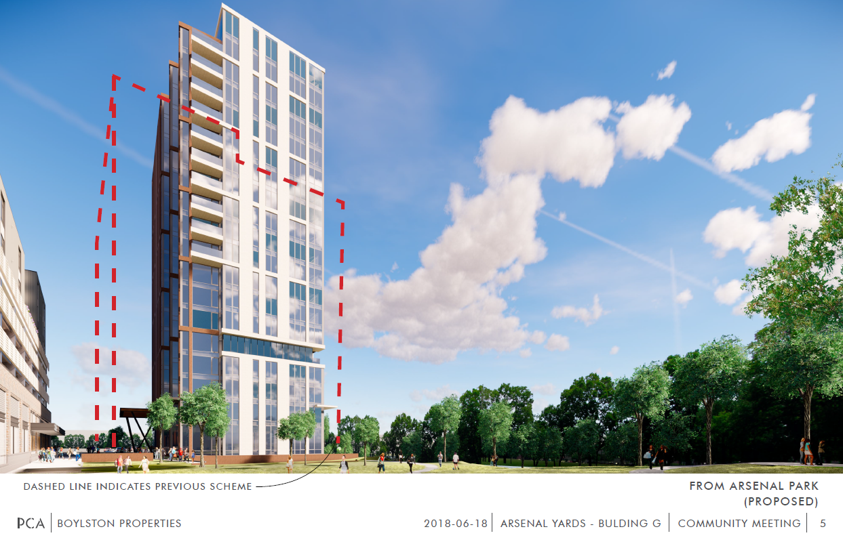

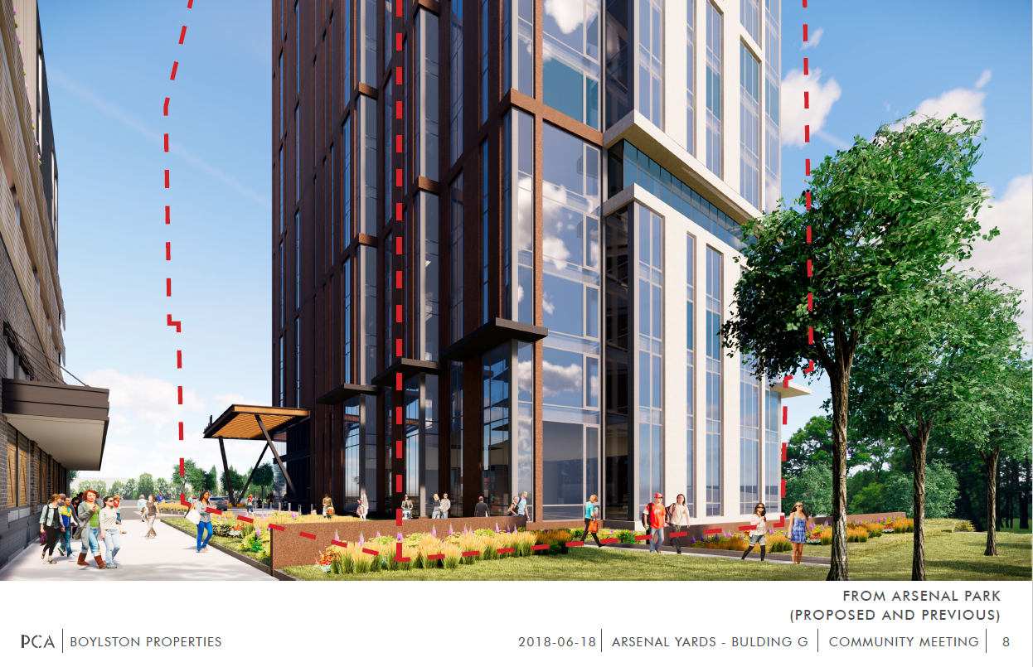
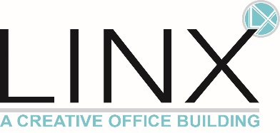
Completed Summer 2017
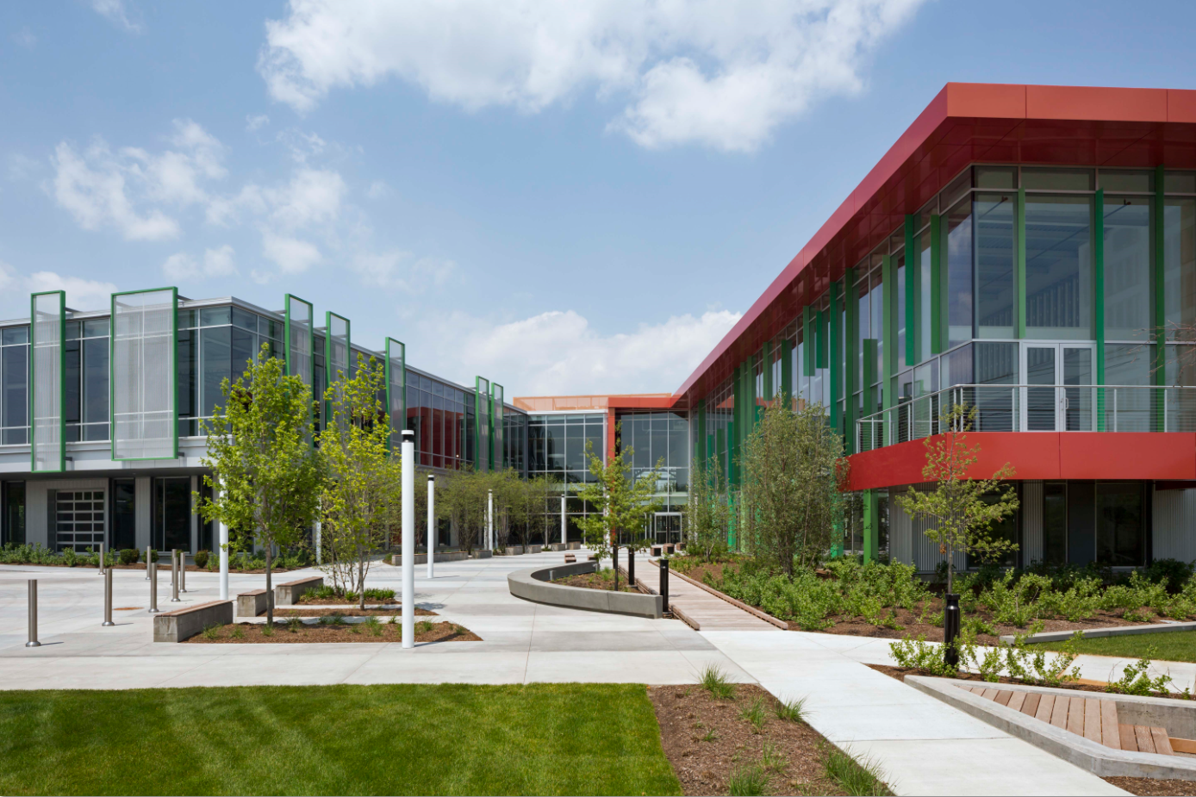

Completed Summer 2016
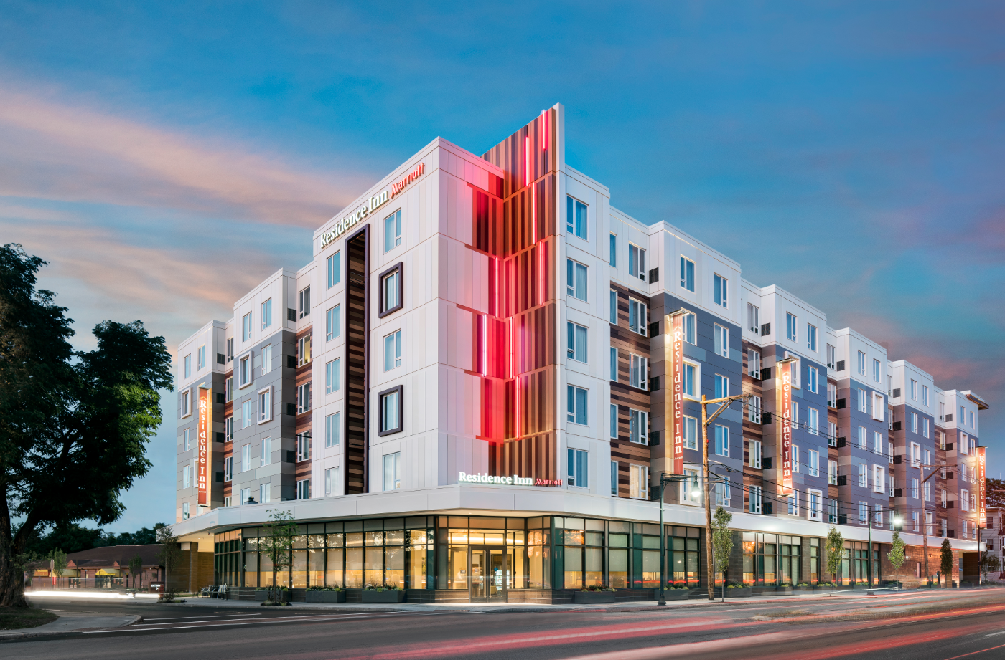

Boylston Properties development in Watertown make a difference:

134 Coolidge Ave, Watertown
Purchased October 1999 (Assessed at $1,230,100)
Sold April 2005 (Assessed at $3,299,800)
Town made an additional $35,196/year in tax revenue after Boylston

LINX, 490 Arsenal Way, Watertown
Purchased July 2014 (Assessed at $9,135,500)
Construction Completed Summer 2017 (Currently Assessed $38,215,400)
Town makes an additional $685,817/year in tax revenue

The Residence Inn, 570 Arsenal Street, Watertown
Purchased December 2012 (Assessed at $2,710,500)
Construction Completed Summer 2016 (Currently Assessed $15,029,000)
Town makes an additional $297,957/year in tax revenue (plus almost $640,000/year in Hotel Occupancy Tax)

Arsenal Yards, Watertown
Purchased August 2013 (Assessed at $41,889,000)
Pre-Development in 2018 (Currently Assessed $76,417,700)
Town makes an additional $782,524.65/year in tax revenue – This is before construction even begins

